Date: 5/12/2025

Day: Sunday


Company: Employee Management System

Done By: Zaid Jehad Tabatebi

ID: 2110012

Instructor: Dr.Rami Ibrahim

Course: Computer Skills
Company: Employee Management System

Abstract:

One essential part of the Visual Basic-developed Company Management System is the Employees Registration Module. The purpose of this module is to make the process of adding new employees to the Company database more efficient and straightforward. Improving employees’ management efficiency is the aim, with a focus on providing employees and managers with accurate and easily accessible information.

Introduction:

Influential employees and managers Management module is included in the Visual Basic-based Company Management System. The addition of new employees and information about them will be handled by this module with efficiency, improving the company's information management system's overall performance.

A Company facility's various administrative, management, and financial tasks can be streamlined and optimized with the help of an all-inclusive and integrated software solution known as a Company Management System (CMS). Improving company operations' overall efficacy, precision, and efficiency is the main objective of the system.

The System Forms:

This system consisted of nine forms for a Company management system

- The system ask the user to enter user name and password first form.

- Then the user choose if he is a Manager, Employee or Finance second form.

- Manager choice will bring the third form which asks the manager to enter the secret code
“12345**”.

- Then it would take the user to the 4th form which give permission to add new employee information and he can choose to register or exit the page.

- In this 5th form after clicking register it will print out the basic information of the new employee.

- Employee choice will bring the 6th form which asks the manager to enter the secret code
“1234**” or if the user is manager “12345**”.

- In case the user chooses Employee it would take him to the 7th form which has the ability to show information about the employees in the company by their ID and go back to the previous form.

- Finance choice will bring the 8th form which asks the manager to enter the secret code only if the user is manager “12345**”.
- Lastly the 9th form asks the user to input the No. of employees and the salary to calculate the total expenses.

Results:
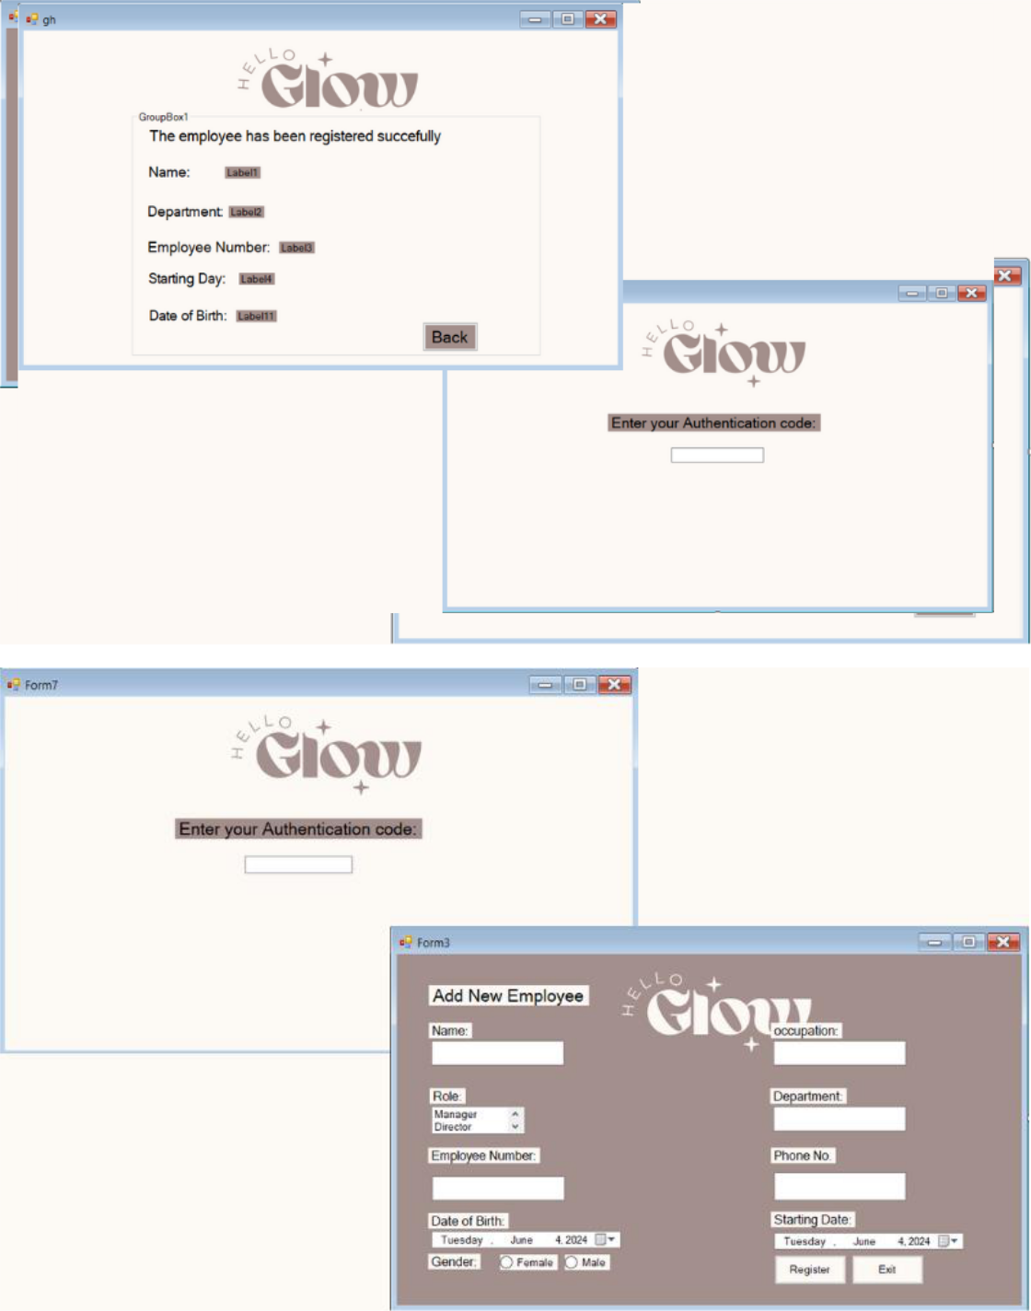
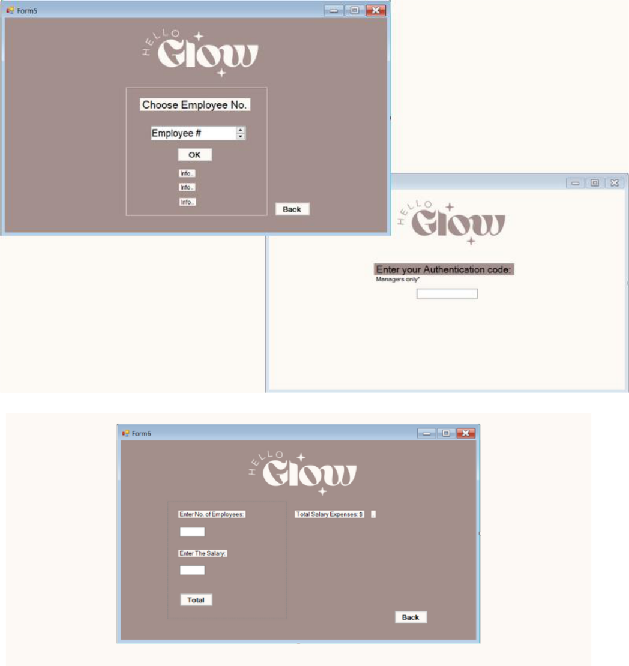

Conclusion:

The Managers and Staff Management module in the Company Management System, developed using Visual Basic, enhances the operational efficiency of HR Work. By providing an intuitive interface for employees’ registration and staff recruitment, the system contributes to accurate record-keeping, streamlined workflows, and improved overall management within the company.

